Mobile App Testing
Fundamentals

1. Installasi Zulu JDK
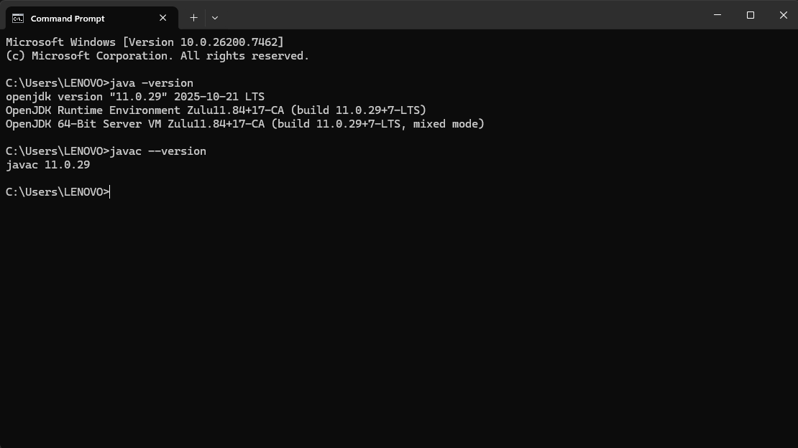

2. Installasi Appium Server
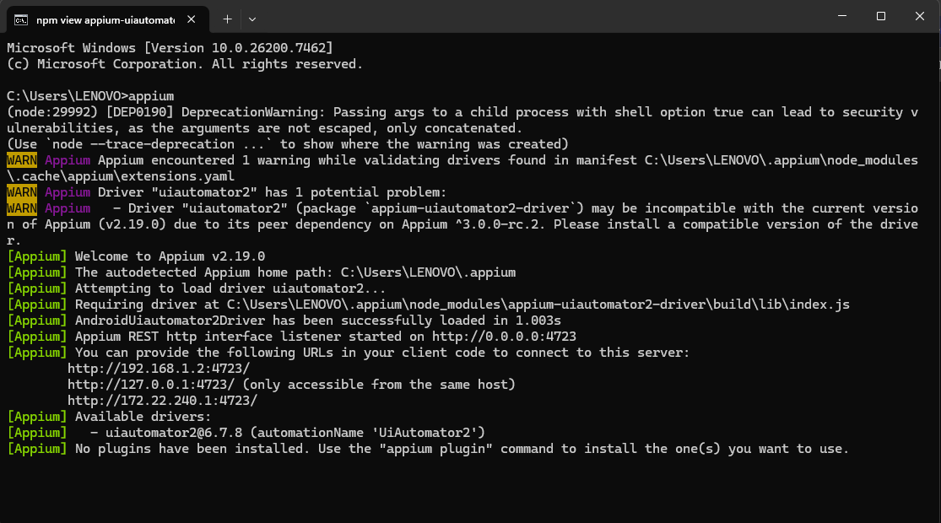

3. Installasi Android Studio dan SDK
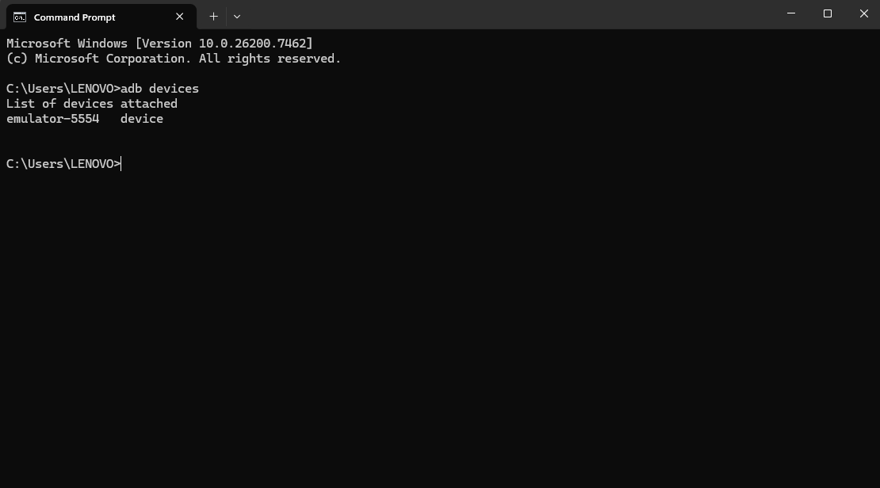

4. Installasi Appium Inspector
